

Assignment - 1

# **WICO Dataset Analysis Report**

### ***Comparing Malicious vs. Benign Twitter Subgraphs Using Gephi***

Fadya Hesham Elorabi

2205177

**- Introduction**

This analysis compares a malicious and a benign Twitter community from the WICO Graph Dataset.  
 One graph was taken from the 5G_Conspiracy_Graphs folder and represents a misinformation cluster about 5G.  
 The second graph was taken from the Non_Conspiracy_Graphs folder and represents a normal discussion cluster.

The goal is to see how the structure of a misinformation network differs from a normal network on Twitter

REF : <https://www.kaggle.com/datasets/arashnic/misinfo-graph>

# **1. Edges**

**Non-Conspiracy:** 37  
 **5G Conspiracy:** 94

### **What it means**

5g graph has X 3 the normal graph

This conc to-> more retweets -> specially in the echo chambers

# **2. Average Degree**

**Non-Conspiracy:** 1.121  
 **5G Conspiracy:** 3.032

### **Why it signals misinformation**

* 5g G has X 3 the normal

# **3. Graph Density**

**Non-Conspiracy:** 0.035  
 **5G Conspiracy:** 0.101

### **Why it signals misinformation**

* Everyone interacts with everyone else more than the normal graph about X3
* As a result of the echo chambers tightly coupled looping interactions

# **4. Average Clustering Coefficient**

**Non-Conspiracy:** 0.112  
 **5G Conspiracy:** 0.394

### **Why it signals misinformation**

**5G Conspiracy** is X3 s the **normal G**

High clustering = **echo chambers** → isolated belief groups → rapid reinforcement of false claims. → after forming string chambers → it moves to the general population → through bridge nodes(high btwness)

# **5. Modularity (Q)**

**Non-Conspiracy:** 0.347  
 **5G Conspiracy:** 0.162

### **Why misinformation networks have lower modularity**

* Due to the Bridge nodes as Target is--> misinformation spreads widely

# **6. Connected Components**

**Non-Conspiracy:** 9  
 **5G Conspiracy:** 7

### **Why it signals misinformation**

* misinformation spreads between groups instead of staying isolated[AS THEIR EXISTS BRIDGE NODES] ->LESS FRAGMNENTED

# **7. Diameter**

**Non-Conspiracy:** 4  
 **5G Conspiracy:** 5

### **What it means**

As The misinformation network is broad -> higher diameter indicates -> network is broader

# 8.suspicious nodes

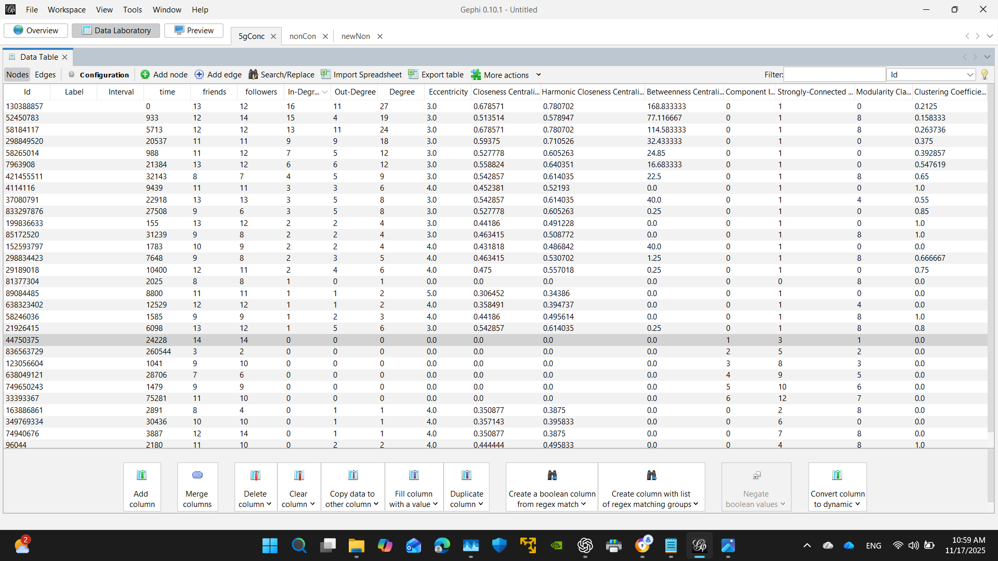

**bot master**

This node (ID **130388857**) has:

* **Degree = 27** ← highest
* **Betweenness = 168.83** ← highest
  + INDICATES C&C --> MASTER --> **Command and Control**
* **Other potential bots / bridges->**
* 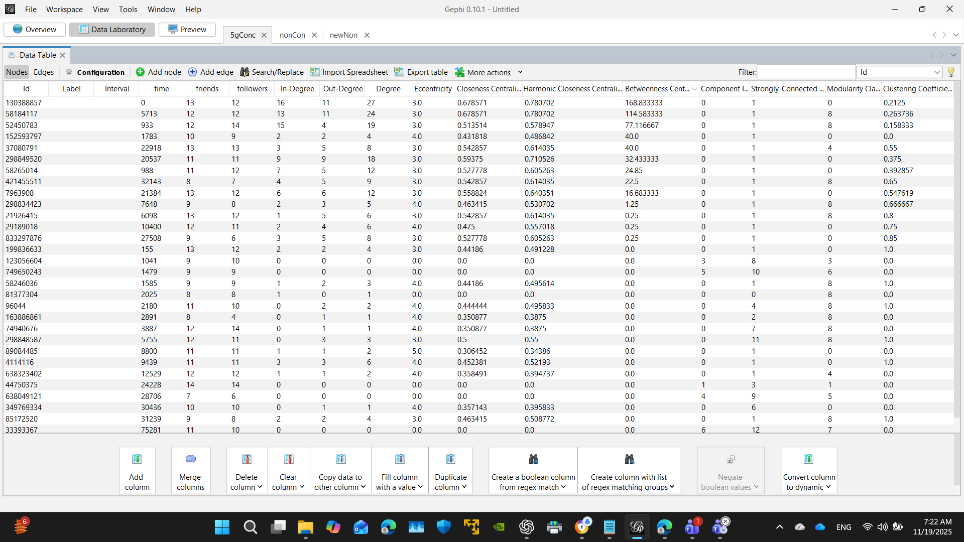

This means:

### **1) Many users interact with it (in-degree high)**

It receives messages/retweets from many accounts.

### **2) It interacts with many users (out-degree high)**

It pushes content outwards to many accounts.

### **3) It sits on the MOST shortest paths (highest betweenness)**

If this node disappears, the network partially collapses.

**fake-follower**

**Ub-normal ratio in:out**

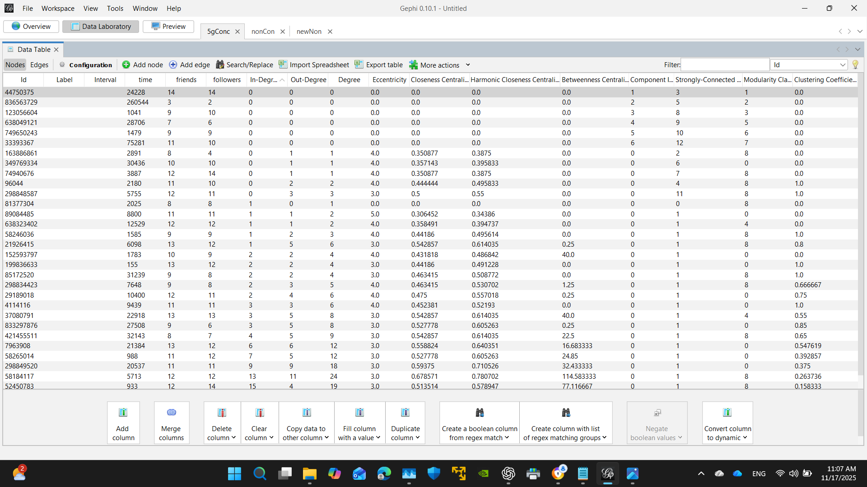

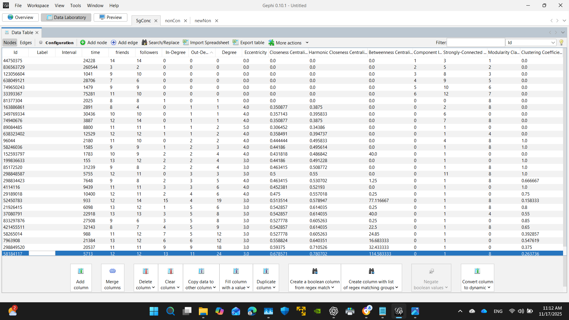

# 9.Betweenness & Centrality:

### **Non-Conspiracy Plot**

* Almost all nodes have low influence
* Only a couple nodes reach values around 5 to near 7

# 

### **5G Conspiracy Plot**

* Still many nodes have betweenness near zero

but:

* + Several nodes in mid-range (20–60)
  + One or two *extreme* nodes at 110,170->INDICATES C&C-->MASTER-->**Command and Control**
  + **Some nodes function as super-spreaders or bots as we concluded prevoulsy**

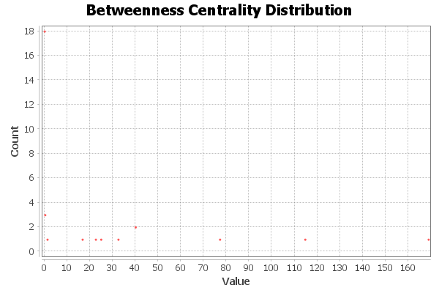

---------------------------------------------------------------------

5G Conspiracy Closeness

* **Closeness cluster at 0.4-0.8–1.0**
* Higher than the normal G
* High closeness/eigenvector nodes spread information quickly->mis-info-spread is higher

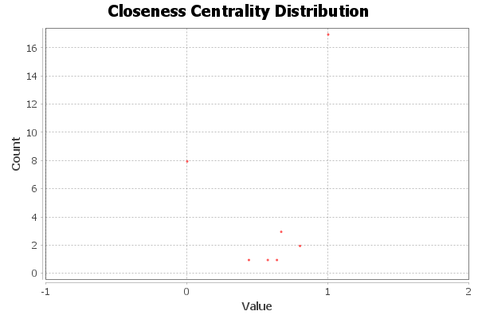

NON-CONSPIRACY Closeness

Closeness around 0.3–0.6 only

No nodes strongly connected to everybody

